**Problem set 2:**

**AQ1**

**SELECT Location_Name**

**,Time_Year**

**,Time_Month**

**,SUM(Quantity_Ordered * Unit_Price) AS AMT**

**,SUM(SUM(Quantity_Ordered * Unit_Price)) OVER (**

**PARTITION BY Location_Name**

**,Time_Year ORDER BY Time_Month ROWS UNBOUNDED PRECEDING**

**) AS CUMSUMAMT**

**FROM W_JOB_F**

**,W_LOCATION_D**

**,W_TIME_D**

**WHERE W_JOB_F.Location_ID = W_LOCATION_D.Location_ID**

**AND W_TIME_D.Time_id = W_JOB_F.Contract_date**

**GROUP BY Location_Name**

**,Time_Year**

**,Time_Month;**

**Result:388 rows**

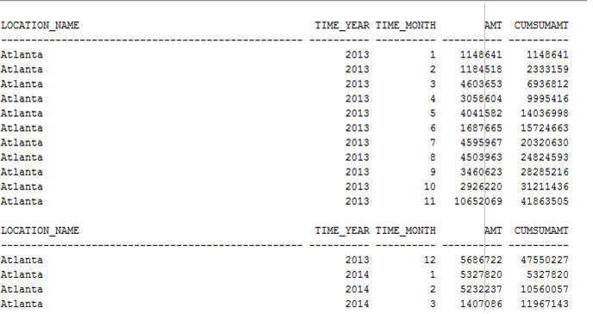

**AQ2**

**SELECT Location_Name**

**,Time_Year**

**,Time_Month**

**,AVG(Quantity_Ordered * Unit_Price) AS AVGAMT**

**,AVG(AVG(Quantity_Ordered * Unit_Price)) OVER (**

**PARTITION BY Location_Name ORDER BY Time_Year**

**,Time_Month ROWS 11 PRECEDING**

**) AS AVGSUMAMT**

**FROM W_JOB_F**

**,W_LOCATION_D**

**,W_TIME_D**

**WHERE W_JOB_F.Location_ID = W_LOCATION_D.Location_ID**

**AND W_TIME_D.Time_id = W_JOB_F.Contract_date**

**GROUP BY Location_Name**

**,Time_Year**

**,Time_Month;**

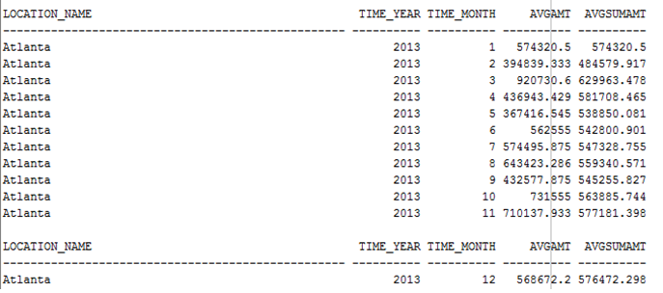

**AQ3**

**SELECT BQ2.Location_Name**

**,BQ2.Time_Year**

**,BQ2.Time_Month**

**,SUM(SUMINVAMT - TOTALCOST) AS Profit**

**,RANK() OVER (**

**PARTITION BY BQ2.Time_Year ORDER BY SUM(SUMINVAMT - TOTALCOST) DESC**

**) AS Rank**

**FROM BQ2**

**,BQ3**

**WHERE BQ2.Job_id = BQ3.Job_id**

**GROUP BY BQ2.Location_Name**

**,BQ2.Time_Year**

**,BQ2.Time_Month;**

**Result: (312 rows)**

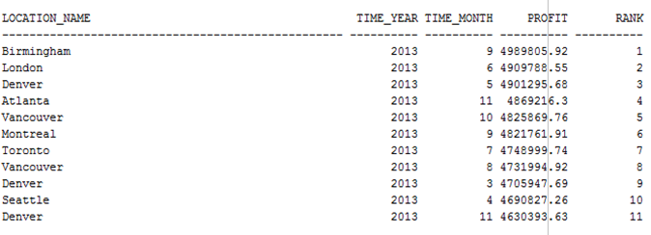

**AQ4**

**SELECT BQ2.Location_Name**

**,BQ2.Time_Year**

**,BQ2.Time_Month**

**,SUM(SUMINVAMT - TOTALCOST) / SUM(SUMINVAMT) AS ProfitMargin**

**,RANK() OVER (**

**PARTITION BY BQ2.Time_Year ORDER BY SUM(SUMINVAMT - TOTALCOST) / SUM(SUMINVAMT) DESC**

**) AS Rank**

**FROM BQ2**

**,BQ3**

**WHERE BQ2.Job_id = BQ3.Job_id**

**GROUP BY BQ2.Location_Name**

**,BQ2.Time_Year**

**,BQ2.Time_Month;**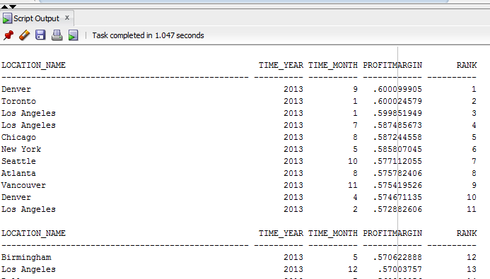

**AQ5**

**SELECT BQ2.Job_Id**

**,BQ2.Location_Name**

**,BQ2.Time_Year**

**,BQ2.Time_Month**

**,SUM(SUMINVAMT - TOTALCOST) / SUM(SUMINVAMT) AS ProfitMargin**

**,PERCENT_RANK() OVER (**

**ORDER BY SUM(SUMINVAMT - TOTALCOST) / SUM(SUMINVAMT) DESC**

**) AS PercentRank**

**FROM BQ2**

**,BQ3**

**WHERE BQ2.Job_id = BQ3.Job_id**

**GROUP BY BQ2.Job_Id**

**,BQ2.Location_Name**

**,BQ2.Time_Year**

**,BQ2.Time_Month;**

**Result: (2504 rows)**

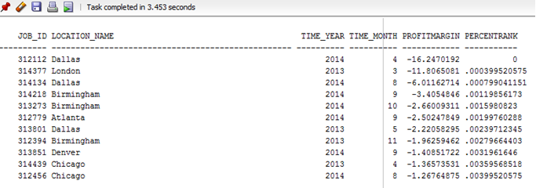**AQ6**

**SELECT \***

**FROM (**

**SELECT BQ2.Job_Id**

**,BQ2.Location_Name**

**,BQ2.Time_Year**

**,BQ2.Time_Month**

**,SUM(SUMINVAMT - TOTALCOST) / SUM(SUMINVAMT) AS ProfitMargin**

**,PERCENT_RANK() OVER (**

**ORDER BY SUM(SUMINVAMT - TOTALCOST) / SUM(SUMINVAMT) DESC**

**) AS PercentRank**

**FROM BQ2**

**,BQ3**

**WHERE BQ2.Job_id = BQ3.Job_id**

**GROUP BY BQ2.Job_Id**

**,BQ2.Location_Name**

**,BQ2.Time_Year**

**,BQ2.Time_Month**

**)**

**WHERE PercentRank < 0.05;**

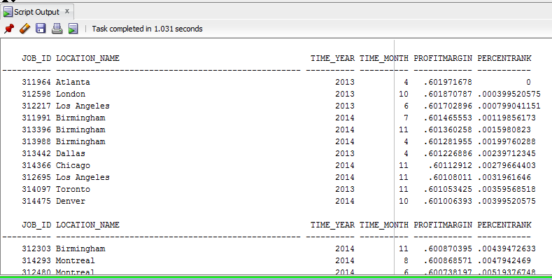**AQ7**

**SELECT Sales_Class_Desc**

**,Time_Year**

**,SUM(Quantity_shipped - Invoice_Quantity) AS QTYRETURNED**

**,RANK() OVER (**

**PARTITION BY Time_Year ORDER BY SUM(Quantity_shipped - Invoice_Quantity) DESC**

**) AS Rank**

**FROM W_INVOICELINE_F**

**,W_Sales_Class_D**

**,W_TIME_D**

**WHERE quantity_shipped - invoice_quantity > 0**

**AND W_INVOICELINE_F.INVOICE_SENT_DATE = W_TIME_D.TIME_ID**

**AND W_INVOICELINE_F.Sales_Class_Id = W_Sales_Class_D.Sales_Class_Id**

**GROUP BY Sales_Class_Desc**

**,Time_Year;**

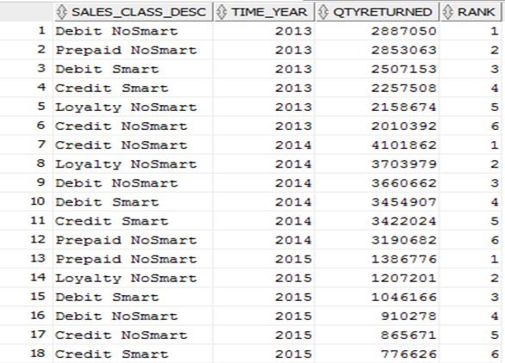

**AQ8**

**SELECT Sales_Class_Desc**

**,Time_Year**

**,SUM(Quantity_shipped - Invoice_Quantity) AS QTYRETURNED**

**,RATIO_TO_REPORT(SUM(Quantity_shipped - Invoice_Quantity)) OVER (PARTITION BY Time_Year) AS Ratio**

**FROM W_INVOICELINE_F**

**,W_Sales_Class_D**

**,W_TIME_D**

**WHERE quantity_shipped - invoice_quantity > 0**

**AND W_INVOICELINE_F.INVOICE_SENT_DATE = W_TIME_D.TIME_ID**

**AND W_INVOICELINE_F.Sales_Class_Id = W_Sales_Class_D.Sales_Class_Id**

**GROUP BY Sales_Class_Desc**

**,Time_Year**

**ORDER BY Time_Year**

**,QTYRETURNED;**

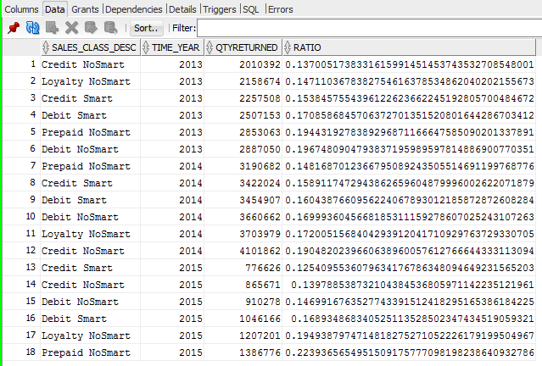**AQ9**

**SELECT Location_Name**

**,W_Time_D.Time_Year**

**,SUM(DAYSDIFF) AS SUMDAYSDIFF**

**,RANK() OVER (**

**PARTITION BY W_Time_D.Time_Year ORDER BY SUM(DAYSDIFF) DESC**

**) AS Rank**

**,DENSE_RANK() OVER (**

**PARTITION BY W_Time_D.Time_Year ORDER BY SUM(DAYSDIFF) DESC**

**) AS DenseRank**

**FROM BQ6**

**,W_Time_D**

**WHERE W_Time_D.Time_Id = BQ6.Date_Ship_By**

**GROUP BY Location_Name**

**,W_Time_D.Time_Year;**

Result: (27 rows)

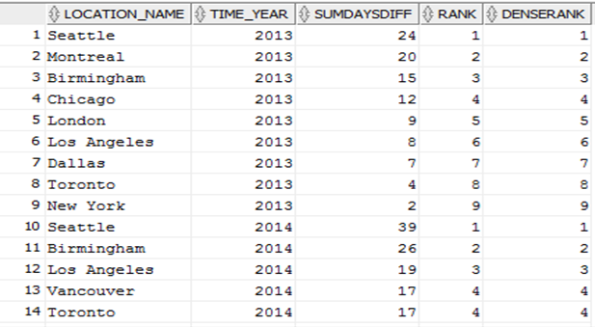

**AQ10**

**SELECT Location_Name**

**,W_Time_D.Time_Year**

**,SUM(DAYSDIFF) AS SUMDAYSDIFF**

**,Count(*) AS NoofJobs**

**,SUM(Quantity_Ordered - SumShipQty) / SUM(Quantity_Ordered) AS Delay_Rate**

**,RANK() OVER (**

**PARTITION BY W_Time_D.Time_Year ORDER BY SUM(Quantity_Ordered - SumShipQty) / SUM(Quantity_Ordered) DESC**

**) AS Rank**

**FROM BQ5**

**,W_Time_D**

**WHERE W_Time_D.Time_Id = BQ5.Date_Promised**

**GROUP BY Location_Name**

**,W_Time_D.Time_Year;**

Result: 27 rows

